**Hello World RESTful Web Service** 

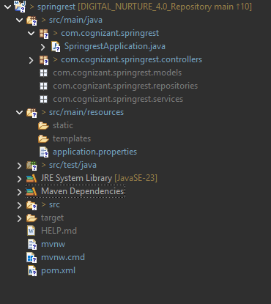

<?xml version="1.0" encoding="UTF-8"?>

<project xmlns="http://maven.apache.org/POM/4.0.0" xmlns:xsi="http://www.w3.org/2001/XMLSchema-instance"

xsi:schemaLocation="http://maven.apache.org/POM/4.0.0 https://maven.apache.org/xsd/maven-4.0.0.xsd">

<modelVersion>4.0.0</modelVersion>

<parent>

<groupId>org.springframework.boot</groupId>

<artifactId>spring-boot-starter-parent</artifactId>

<version>3.5.3</version>

<relativePath/> <!-- lookup parent from repository -->

</parent>

<groupId>com.cognizant</groupId>

<artifactId>springrest</artifactId>

<version>0.0.1-SNAPSHOT</version>

<name>springrest</name>

<description>Demo project for Spring Boot</description>

<url/>

<licenses>

<license/>

</licenses>

<developers>

<developer/>

</developers>

<scm>

<connection/>

<developerConnection/>

<tag/>

<url/>

</scm>

<properties>

<java.version>24</java.version>

</properties>

<dependencies>

<dependency>

<groupId>org.springframework.boot</groupId>

<artifactId>spring-boot-starter-data-jpa</artifactId>

</dependency>

<dependency>

<groupId>org.springframework.boot</groupId>

<artifactId>spring-boot-starter-web</artifactId>

</dependency>

<dependency>

<groupId>org.springframework.boot</groupId>

<artifactId>spring-boot-devtools</artifactId>

<scope>runtime</scope>

<optional>true</optional>

</dependency>

<dependency>

<groupId>com.mysql</groupId>

<artifactId>mysql-connector-j</artifactId>

<scope>runtime</scope>

</dependency>

<dependency>

<groupId>org.springframework.boot</groupId>

<artifactId>spring-boot-starter-test</artifactId>

<scope>test</scope>

</dependency>

</dependencies>

<build>

<plugins>

<plugin>

<groupId>org.springframework.boot</groupId>

<artifactId>spring-boot-maven-plugin</artifactId>

</plugin>

</plugins>

</build>

</project>

spring.application.name=springrest

spring.datasource.driver-class=com.mysql.cj.jdbc.Driver

spring.datasource.url=jdbc:mysql://localhost:3306/country

spring.datasource.username=root

spring.datasource.password=root

server.port=8080

spring.jpa.hibernate.ddl=update

spring.jpa.properties.hibernate.dialect=org.hibernate.dialect.MySQL8Dialect

package com.cognizant.springrest;

import org.slf4j.Logger;

import org.slf4j.LoggerFactory;

import org.springframework.boot.SpringApplication;

import org.springframework.boot.autoconfigure.SpringBootApplication;

*@SpringBootApplication*

public class SpringrestApplication {

private static final Logger ***LOGGER*** = LoggerFactory.*getLogger*(SpringrestApplication.class);

public static void main(String[] args) {

***LOGGER***.info("Started Main");

SpringApplication.*run*(SpringrestApplication.class, args);

***LOGGER***.info("End of Main");

}

}

}

